CITS4401 Software Requirements and Design

Research Ethics Management System (REMS): Phase 2
System Architecture Diagram
Group 14
Team Members:
STUDENT ID | STUDENT NAME
24993619 | Chen Di
24269773 | Xu Li
25080771 | Moolampally Ananya
24758299 | Ouyang Thomas
24692035 | Sajimon Joseph Chris
24591632 | Atharva Ganesh Dalvi Dalvi

Date: 30 April 2026

- SYSTEM ARCHITECTURE DIAGRAM:
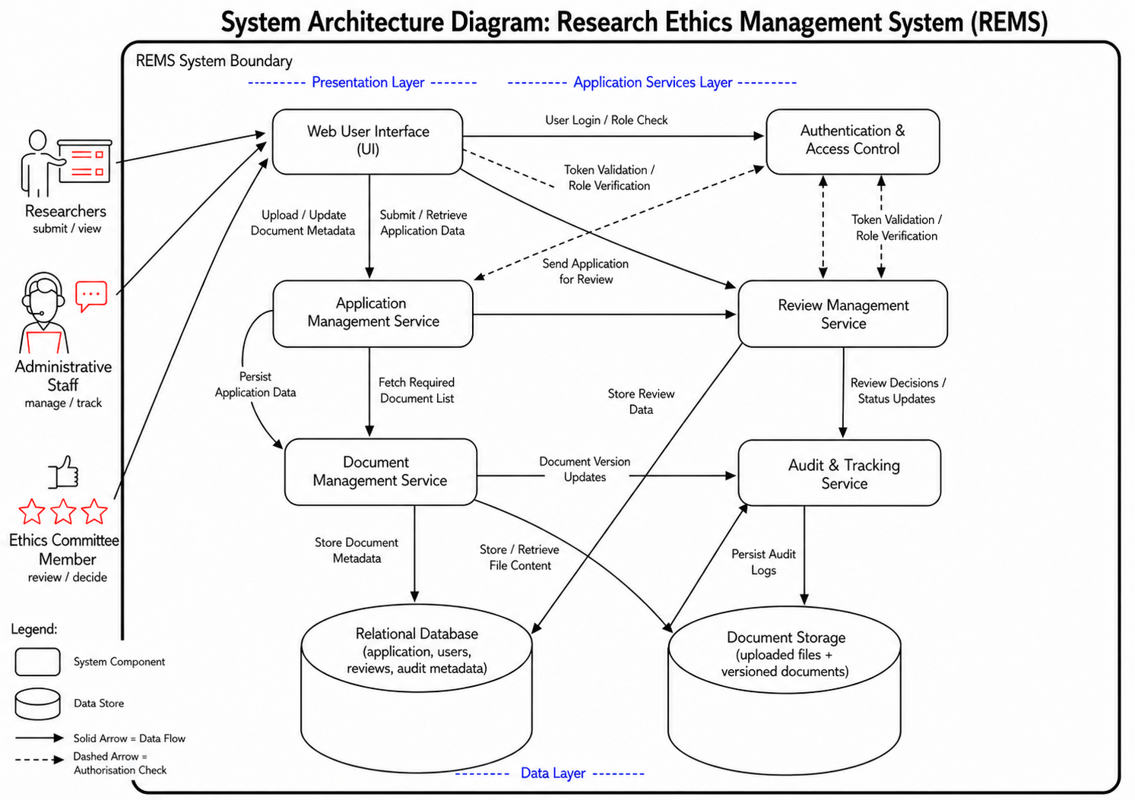

1.1 SYSTEM ARCHITECTURE OVERVIEW:
The Research Ethics Management System (REMS) follows a layered architecture with three main layers: the Presentation Layer, Application Services Layer, and Data Layer. This structure separates user interaction, system logic, and data storage, making the system easier to manage and extend.
1.1.1 PRESENTATION LAYER:
This layer contains the Web User Interface (UI), which is used by Researchers, Administrative Staff, and Ethics Committee Members. All users interact with the system through this interface to submit applications, upload documents, track progress, and review decisions. The UI also sends login requests to the Authentication and Access Control component.
1.1.2 APPLICATION SERVICES LAYER:
This layer contains the main system functionality. The Authentication and Access Control component verifies user identity and roles before allowing access. The Application Management Service handles application submission, retrieval, updates, and forwards applications for review. The Document Management Service manages document uploads, stores metadata, handles file storage, and tracks document versions. The Review Management Service processes review decisions and updates application status. The Audit and Tracking Service records key system activities such as submissions, updates, and decisions.
1.1.3 DATA LAYER:
This layer stores all system data. A Relational Database stores structured data such as applications, users, reviews, and audit records. A separate Document Storage system stores uploaded files and their versions. This separation improves performance and efficient data handling.
Solid arrows in the diagram represent data flow between components, such as application data, documents, and review results. Dashed arrows represent authorisation checks, where services verify user roles through the Authentication component before processing requests.
Overall, this architecture supports all key system functions while ensuring clear structure, security, and efficient data management.

